**PROFESSIONAL TRAINING REPORT**

**at**

**Sathyabama Institute of Science and Technology**

**(Deemed to be University)**

Submitted in partial fulfillment of the requirements for the award of Bachelor of Engineering degree in Computer Science and Engineering

By

**VENKATA HARSHA UDAY MATTAPARTHI**

**(Reg. No – 42111546)**



**DEPARTMENT OF COMPUTER SCIENCE ENGINEERING**

**SCHOOL OF COMPUTING**

SATHYABAMA

INSTITUTE OF SCIENCE AND TECHNOLOGY

(DEEMED TO BE UNIVERSITY)

CATEGORY- 1 UNIVERSITY BY UGC

Accredited “A++” by NAAC I Approved by AICTE

**JEPPIAAR NAGAR, RAJIV GANDHI SALAI CHENNAI - 600119**

**OCTOBER - 2024**



**DEPARTMENT OF COMPUTER SCIENCE AND ENGINEERING**

**BONAFIDE CERTIFICATE**

This is to certify that this Professional Training-1 Report is the Bonafide work of **VENKATA HARSHA UDAY MATTAPARTHI (Reg. No- 42111546)** who carried out the Project entitled **“ONLINE JEWELLERY STORE Using Full Stack Web Development”** under my supervision from June 2024 to October 2024.

**Internal Guide**

**Dr. Srideivanai Nagarajan, M.C.A., M.Phil., Ph.D.,**

**Head of the Department**

**Dr. L. LAKSHMANAN, M.E., Ph.D.,**

**Submitted for Interdisciplinary Viva Voce Examination held on**

**Internal Examiner External Examiner**

## DECLARATION

I, **VENKATA HARSHA UDAY MATTAPARTHI (Reg. No - 42111546),** hereby declare that the Professional Training-1 Report entitle **“ONLINE JEWELLERY STORE using Full Stack Web Development”** done by me under the guidance of  **Dr.Srideivanai Nagarajan, M.C.A., M.Phil., Ph.D.,** is submitted in partial fulfillment of the requirements for the award of Bachelor of Engineering degree in **Computer Science and Engineering**.

## DATE:

## PLACE: Chennai SIGNATURE OF THE CANDIDATE

## ACKNOWLEDGEMENT

I am pleased to acknowledge my sincere thanks to **BOARD OF MANAGEMENT** of **Sathyabama Institute of Science and Technology** for their kind encouragement in doing this project and for completing it successfully. I am grateful to them.

I convey my thanks to **Dr. T. Sasikala, M.E., Ph. D.**, **Dean**, School of Computing, and **Dr. L. Lakshmanan, M.E., Ph.D., Head of the Department** of Computer Science and Engineering for providing me with necessary support and details at the right time during the progressive reviews.

I would like to express my sincere and deep sense of gratitude to my Project Guide **Dr. Srideivanai Nagarajan, M.C.A., M.Phil., Ph.D.,** for her valuable guidance, suggestions, and constant encouragement paved the way for the successful completion of my project work.

I wish to express my thanks to all Teaching and Non-teaching staff members of the Department of Computer Science and Engineering who were helpful in many ways for the completion of my project

# TRAINING CERTIFICATE



# ABSTRACT

The Online Jewellery Shop application simplifies the process of buying the latest jewellery designs across categories like Gold, Silver, and Diamond. It replaces traditional paper-based and desktop methods with an efficient, server-based system that allows users to handle registration, manage transactions, and maintain a centralized database that updates in real-time. Multiple users can access the system simultaneously, and it offers features to generate management reports (PDF, Excel) for event organizing. The application reduces manual efforts in handling data and provides an intuitive interface for users to view event details, streamlining the entire shopping experience. The Online Jewellery Shop application is designed to provide users with an easy and convenient way to browse and purchase the latest jewellery designs in different categories such as Gold, Silver, and Diamond`. This platform caters to both customers and the management of the shop by streamlining operations that are traditionally managed through manual paperwork or desktop applications like MS Excel. The application runs on a server, allowing multiple users to log in and use the system simultaneously. This feature ensures that any updates or changes made to the inventory, user data, or transactions are immediately reflected across all locations in real time. Users can easily register, view product details, and place orders with just a few clicks. One of the key advantages of the system is its ability to generate various types of management reports, such as PDF or Excel formats, which are crucial for business activities like event planning and sales tracking. The Online Jewellery Shop automates essential business processes, reducing manual effort and minimizing errors. Its centralized database optimizes inventory management and eliminates the need for manual records. This enhances the user experience and streamlines daily operations for the administration.

## TABLE OF CONTENTS

|  |  |  |
| --- | --- | --- |
| **CHAPTER No.**  1  2  3  4  5  6  7  8  9  10 | **TITLE**  ABSTRACT  LIST OF FIGURES  INTRODUCTION  USER FEATURES  WEBSITE DESIGN  SYSTEMN ANALYSIS  DEVELOPMENT TOOLS AND TECHNIQUES  SYSTEM DESIGN  MODULE IMPLEMENTATION  RESULT & DISCUSSION  CONCLUSION&FUTURE ENHANCEMENT  9.1 CONCLUSION  9.2 ENHANCEMENT  REFERENCES | **PAGE No.**  Vi  viii    1  2  6  10  14  18  22  26  28  28  28  30 |

**LIST OF FIGURES**

|  |  |  |
| --- | --- | --- |
| **CHAPTER No.**  5.1  5.2  5.3  6.1  6.2  6.3  6.4  7.1  7.2  7.3  7.4  7.5 | **TITLE**  HTML  CSS  JAVA  ER DIAGRAM  DATA FLOW DIAGRAM  USE CASE DIAGRAM  CLASS DIAGRAM  LOGIN POPUP  HOME PAGE  SHOP PAGE  CART PAGE  WISHLIST | **PAGE No.**  14  14  16  18  19  20  21  23  23  24  24  25 |

**CHAPTER 1**

**INTRODUCTION**

**OVERVIEW**

An online jewellery store should combine luxury and functionality, offering a visually engaging design with smooth navigation. The homepage should prominently feature high-quality images of exclusive pieces, popular collections, and ongoing promotions, encouraging customers to explore categories like rings, earrings, bracelets, and necklaces. Each product page should provide multiple images, detailed descriptions, transparent pricing, and customization options such as resizing or engraving, supported by customer reviews to boost trust. Advanced filtering options based on material, gemstone type, occasion, and price should streamline the shopping process. Secure payment gateways, trust-building certifications (e.g., diamond or gemstone authenticity), and excellent customer support ensure a reliable and enjoyable shopping experience, promoting long-term loyalty and satisfaction.

**PROBLEM STATEMENT**

Online Jewellery Store is a web application designed to provide a seamless shopping experience for customers looking to purchase jewelry. It offers a convenient and accessible platform for browsing, selecting, and buying a wide range of jewelry items, from everyday pieces to high-end luxury items.

Product Catalog: Displays a comprehensive range of jewelry items, including rings, necklaces, bracelets, and earrings, with high-quality images, detailed descriptions, and specifications such as metal type, gemstone details, and carat weight.

Search and Filters: Allows users to search for specific items and apply filters based on criteria like type, price range, material, and gemstone, helping them find desired pieces quickly.

**CHAPTER 2**

**USER FEATUERS**

**1. USER FRIENDLY NAVIGATION**

An online jewellery store should prioritize user-friendly navigation to create a seamless shopping experience, allowing customers to effortlessly browse various categories such as rings, necklaces, bracelets, and earrings. Implementing a well-structured mega menu is essential for larger collections, as it provides easy access to subcategories like engagement rings or wedding bands, helping users quickly find specific items. Additionally, a prominent search bar with autocomplete suggestions enhances usability by guiding customers to relevant products as they type. Incorporating filters for product types, materials, and price further streamlines the search process, ensuring that users can easily locate their desired jewellery without frustration, ultimately increasing their likelihood of making a purchase.

**2. FILTERING OPTIONS**

Advanced **product filtering options** are essential for enhancing the shopping experience in an online jewellery store, as they allow users to find exactly what they are looking for with ease. Customers should be able to filter items by material, such as gold, silver, or platinum, as well as by gemstone type, including diamonds, sapphires, and emeralds, ensuring they can select pieces that meet their preferences. Additionally, incorporating price range filters helps users stay within their budget, making the shopping process more convenient. To further streamline their search, offering filters based on style, occasion, or collection—such as wedding, engagement, or gifts—enables users to narrow down their options quickly, ultimately leading to a more satisfying and efficient purchasing experience.

**3. WISH LIST**

A **wish list** feature is a valuable addition to an online jewellery store, allowing customers to save their favorite items for future reference or gift planning, enhancing their shopping experience. This feature can be complemented by **shareable wish lists**, which are particularly useful during gift-giving occasions,

enabling users to easily share their desired items with friends and family for special

celebrations. Moreover, displaying customer reviews and user-generated photos alongside products significantly boosts credibility, helping potential buyers trust the quality and authenticity of the jewellery. This social proof not only encourages more informed purchasing decisions but also fosters a sense of community among shoppers, ultimately leading to increased customer satisfaction and loyalty.

**4. PRODUCT CUSTOMIZATION**

Offering **product customization** features greatly enhances the appeal of an online jewellery store by providing customers with the opportunity to create personalized and meaningful pieces that reflect their individual styles and preferences. Customizable options such as ring sizing allow users to ensure a perfect fit, while engraving services enable them to add personal messages or initials, making each item truly unique.

**5. PRODUCT VISUALIZATION**

To enhance product presentation, high-quality **product visualization** is crucial for capturing the attention of potential buyers and providing them with a comprehensive understanding of each item. By offering multiple high-resolution images from various angles, customers can closely inspect intricate details, such as the cut of a gemstone or the finish of a metal, which is vital for jewellery purchases where craftsmanship is paramount. Additionally, incorporating zoom functionality allows users to focus on specific features, helping them appreciate the quality and design intricacies. Many online jewellery stores further elevate the shopping experience by providing a360-degree product view or engaging video demonstrations that showcase the jewellery’s sparkle and craftsmanship in action. These interactive elements not only enhance user engagement but also help build trust and confidence in the products, reducing the likelihood of purchase hesitations and returns. When customers can clearly see the beauty and quality of the jewellery, they are more likely to make informed purchasing decisions, leading to higher satisfaction and loyalty.

**6. AUGMENTED REALITY**

Advanced features like an **augmented reality (AR)** try-on significantly elevate the user experience in online jewellery shopping by allowing customers to virtually try on pieces, such as rings, necklaces, or earrings, directly through their mobile devices or desktops. This interactive tool enables users to visualize how the jewellery will look on them, offering a more personalized and immersive shopping experience that bridges the gap between online and in-store shopping. By seeing how items fit and complement their style in real time, customers can make more informed decisions and feel more confident about their choices, reducing the uncertainty that often comes with purchasing high-value items online. The AR feature also encourages deeper engagement with the store's products, increasing the likelihood of conversions as users can experiment with different styles and combinations before committing to a purchase. Ultimately, this technology not only boosts customer satisfaction by providing a practical, fun, and intuitive way to shop but also helps reduce returns, as users have a clearer idea of what to expect from their selected items.

**7. SECURE AND FLEXIBLE PAYMENT OPTIONS**

For a seamless checkout process, offering **secure and flexible payment options** is crucial in enhancing the customer experience and ensuring a smooth transaction flow. Providing a wide range of payment methods, such as credit and debit cards, PayPal, and digital wallets like Google Pay or Apple Pay, accommodates diverse customer preferences, making the purchasing process more convenient. Additionally, integrating buy now, pay later services like Klarna or After pay appeals to budget-conscious customers by allowing them to split their payments into manageable installments, reducing upfront costs and making high-value jewellery more accessible. These flexible payment options not only cater to different financial needs but also encourage higher cart values, as customers are more likely to make larger purchases when offered the flexibility to pay over time. For international shoppers, the inclusion of automatic currency conversion further simplifies cross-border transactions, removing confusion and ensuring transparency in pricing.

**8. CUSTOMER SERVICE**

Customer support is a critical component in establishing a trustworthy and reliable shopping environment for an online jewellery store. Live chat support offers real-time assistance, addressing customer inquiries or concerns promptly, whether about product details, order status, or return policies. This immediate communication channel helps to resolve issues quickly, enhancing customer satisfaction and building confidence in the brand. In addition to live chat, a well-organized **FAQ section** provides answers to common questions regarding product care, shipping times, return processes, and warranties, making it easier for customers to find information independently without having to wait for support. To further personalize the shopping experience, offering **virtual appointments** with jewellery experts can be invaluable. Through video consultations, customers can receive tailored advice, explore custom jewellery options, and get professional guidance on selecting the perfect piece. This personalized touch not only makes the shopping experience more engaging but also helps build trust, especially for high-value purchases, creating a sense of exclusivity and care. All of these support features combined help create a seamless, customer-centric experience that enhances loyalty and trust in the brand

**CHAPTER 3**

**WEBSITE DESIGN**

**1. VISUAL AESTHETICS AND BRANDING**

**Visual Aesthetics and Branding** are pivotal in creating an online jewellery store that not only attracts but also retains customers by building a sense of trust and luxury. The design should be visually striking yet balanced, with an emphasis on clean, minimalist layouts that allow the jewellery to take center stage. **Consistency in visual elements**, such as the brand's logo, color palette, and font choices, ensures a cohesive identity that strengthens brand recognition and professionalism. The color scheme should reflect the essence of the jewellery whether it's classic gold and silver tones for traditional luxury or softer pastels for modern, chic collections each choice impacting how the brand is perceived. **Typography** must be elegant, often using serif fonts for a high-end feel, while still ensuring legibility across devices. High-resolution **images and videos** are indispensable, allowing customers to see the fine details of the jewellery, and creating an immersive experience that mirrors the feeling of shopping in a physical luxury store. Carefully curated **product displays and lifestyle imagery** also help convey the brand's story and ethos, making the shopping experience not just about products but about aspiration and lifestyle. When done effectively, visual aesthetics and branding combine to establish a strong emotional connection with customers, promoting a sense of exclusivity and desire for the jewellery.

**2. User Interface (UI) Design**

**User Interface (UI) Design** in an online jewellery store is key to creating a seamless, intuitive, and visually appealing shopping experience. A well-designed UI ensures that the layout is clean, easy to navigate, and aesthetically aligned with the brand’s luxury positioning. Layout and structure should be simple yet sophisticated, allowing users to browse effortlessly through product categories without feeling overwhelmed. Clear and prominent call-to-action (CTA) buttons, such as "Add to Cart" or "Buy Now," should be strategically placed and styled to encourage conversions, while maintaining a minimalistic, clutter-free design. Icons and visual elements need to be intuitive and visually consistent, enhancing

navigation and helping users easily identify functions like search, filtering, and wish lists. Product pages should be designed with large, high-resolution images and straightforward options for customization (e.g., size, metal type), making it easy for users to engage with the product. Additionally, ensuring that all interactive elements, like buttons, sliders, and dropdown menus, are responsive and quick-loading helps create a smooth, frustration-free experience, which is crucial in retaining users and driving sales. An effective UI not only elevates the aesthetic quality of the website but also ensures that users can easily and confidently navigate the store from discovery to purchase.

**3. NAVIGATION AND INFORMATION ARCHITECTURE**

**Navigation and Information Architecture** are fundamental to the usability and efficiency of an online jewellery store, ensuring that users can easily find what they are looking for without confusion or frustration. A well-organized menu structure is essential, with clear labels for main categories like rings, necklaces, earrings, and bracelets, alongside subcategories such as engagement rings, gemstones, or collections. This hierarchical approach helps users intuitively explore the site, reducing the cognitive load and improving the overall shopping experience. Breadcrumb navigation is another useful tool, allowing customers to track their path and easily backtrack to previous sections. Search functionality should be highly visible, ideally with autocomplete suggestions and filtering options for product type, material, price, and style, enabling users to refine their search efficiently. Proper information architecture also involves strategically organizing content across the site, ensuring that essential details like shipping information, return policies, and product descriptions are easy to locate and access. A well-thought-out navigation and information structure enhances the user journey, helping them move fluidly from browsing to product selection, all the way to checkout, which ultimately boosts engagement, reduces bounce rates, and increases conversions.

**4. PRODUCT PRESENTATION AND VISUALIZATION**

**Product Presentation and Visualization** are crucial in online jewellery retail, offering customers a rich, immersive experience that mimics in-person shopping. Alongside high-resolution images from multiple angles, many stores also

feature lifestyle images, showing how the jewellery looks when worn, adding emotional appeal and helping customers envision the pieces in real life. Zoom functionality allows users to view intricate details, like gemstone settings or engraving, ensuring they feel confident about the quality and craftsmanship. Advanced visualization tools, such as 360-degree spins or product videos, give a dynamic perspective of the jewellery, highlighting how it catches the light or moves, which is particularly important for pieces with gemstones or chains. Some stores go even further with interactive features, like customizable product views, where users can change gemstone colors or metal types in real time, offering a personalized preview. Incorporating augmented reality (AR) try-on tools gives customers the ability to virtually try on jewellery through their mobile device, providing a highly interactive and personal experience. This level of product presentation enhances customer engagement, fosters trust, and can significantly reduce return rates by giving buyers a clear, detailed understanding of the item before purchasing.

**5. ACCESSBILITY AND INCLUSIVITY**

**Accessibility and Inclusivity** are vital components of an online jewellery store, ensuring that all users, regardless of their abilities or disabilities, can enjoy a seamless shopping experience. Adhering to web accessibility standards, such as the Web Content Accessibility Guidelines (WCAG), helps create an inclusive environment by implementing features like text alternatives for images (alt text), which allow screen readers to describe visuals for visually impaired users. Additionally, ensuring that the website is navigable via keyboard controls accommodates users who cannot use a mouse. Color contrast is another critical aspect; using sufficient contrast between text and background colors enhances readability for individuals with visual impairments. Furthermore, providing transcripts for audio or video content ensures that hearing-impaired users can access the same information as those who can hear. By designing with inclusivity in mind such as offering a variety of font sizes, clear labels for buttons, and responsive layouts that adapt to different devices jewellery stores not only broaden their customer base but also demonstrate a commitment to social responsibility. This inclusivity fosters a positive brand image and enhances customer loyalty, as all users feel valued and respected within the shopping experience.

**6. PERFORMANCE AND LOADING SPEED**

**Performance and Loading Speed** are critical factors that significantly impact the user experience of an online jewellery store. A fast-loading website not only enhances customer satisfaction but also improves search engine rankings, making it easier for potential buyers to find the store. Optimizing image sizes without compromising quality is essential, as high-resolution product images can slow down load times; employing techniques such as compression and responsive image formats ensures quick loading while maintaining visual clarity. Utilizing a Content Delivery Network (CDN) can further improve performance by distributing content across various servers worldwide, allowing for faster access regardless of the user’s location. Additionally, minimizing the use of heavy scripts, reducing HTTP requests, and implementing caching strategies can lead to quicker load times. Regular performance testing and monitoring are vital to identify and rectify any bottlenecks in real-time, ensuring that the website remains responsive even during peak traffic. A swift, well-performing site not only reduces bounce rates but also increases the likelihood of conversions, as customers are more inclined to complete purchases when they can navigate smoothly and efficiently through the online store. Ultimately, prioritizing performance and loading speed creates a more enjoyable and reliable shopping experience, which is crucial for building trust and loyalty among customers

**CHAPTER 4**

**SYSTEM ANALYSIS**

**1. REQUIREMENTS GATHERING**

**Requirements Gathering** for an online jewellery store is a crucial step that involves systematically identifying and analyzing the diverse needs of key stakeholders, including business owners, potential customers, and the technical development team. This process begins by creating detailed user personas that represent various segments of the target audience, encompassing their demographics, shopping behaviors, and specific pain points, such as challenges in product discovery or concerns about the authenticity and quality of jewellery. Functional requirements are then outlined, detailing essential features like product management capabilities, user account functionalities, advanced search options, and a streamlined shopping cart and checkout process to ensure an effortless purchasing experience. Additionally, non-functional requirements are established to address performance metrics, such as fast loading times and responsiveness, alongside security protocols to protect user data and comply with relevant privacy regulations. Accessibility is also a key consideration, ensuring that the platform is inclusive for users with disabilities. By meticulously gathering and evaluating these requirements, the online jewellery store can be crafted to deliver a compelling, user-friendly, and secure shopping experience that aligns with both customer expectations and business goals, ultimately fostering customer loyalty and driving sales.

**2. FUNCTIONAL REQUIREMENTS**

**Functional Requirements** for an online jewellery store encompass a comprehensive set of features designed to ensure a smooth and engaging shopping experience for users. The product management system should allow for the easy addition, editing, and deletion of products, including essential attributes such as categories, descriptions, prices, and inventory levels. User account functionalities must facilitate customer registration, login, password recovery, and profile management, enabling features like wish lists and order history for personalized shopping experiences. The search functionality should be robust, offering advanced

search options with filters for categories, materials, gemstones, and price ranges to

help customers quickly locate desired items. Additionally, the shopping cart must enable users to add or remove items effortlessly, view total costs, and proceed to a secure checkout process that supports multiple payment methods, including credit/debit cards, digital wallets, and buy now, pay later options. To enhance customer satisfaction, the system should also incorporate comprehensive customer support features, such as live chat, FAQs, and contact forms, ensuring that assistance is readily available. Overall, these functional requirements aim to create an efficient, intuitive, and user-friendly online shopping environment that meets the needs of diverse customers while driving sales for the business.

**3. NON-FUNCTIONAL REQUIREMENTS**

**Non-functional requirements** for an online jewellery store are critical aspects that define the quality and performance characteristics of the platform, ensuring it meets user expectations and business goals beyond its functional capabilities. These requirements encompass various dimensions, including **performance**, which dictates how quickly the site should load and respond to user actions, typically aiming for sub-second response times even under high traffic conditions. **Scalability** is essential, allowing the system to handle increasing numbers of users and transactions without degradation in performance, which can be achieved through cloud infrastructure and load balancing strategies. **Security** is a paramount concern, requiring robust measures such as SSL encryption, secure payment processing, and compliance with regulations like GDPR to protect sensitive customer data and maintain trust. **Usability** ensures that the site is intuitive and easy to navigate, accommodating diverse user needs and preferences, which is particularly important in e-commerce to reduce abandonment rates. Additionally, **availability** requirements stipulate that the online store should maintain high uptime, ideally above 99.9%, to ensure customers can shop at any time without interruptions. **Accessibility** is also crucial, ensuring that the site is usable by individuals with disabilities, conforming to standards like the Web Content Accessibility Guidelines (WCAG). Finally, **maintainability** and **reliability** are vital to ensure the system can be easily updated and repaired, minimizing downtime and providing a consistent shopping experience.

**4. SYSTEM ARCHITECTURE**

**System Architecture** for an online jewellery store is a detailed framework that delineates the interaction between various components to create a cohesive and efficient e-commerce platform. The **presentation layer** focuses on the user interface, employing technologies such as HTML, CSS, and modern JavaScript frameworks like React or Angular to deliver a visually appealing, responsive, and intuitive shopping experience across different devices. The **application layer** is where the core business logic resides, utilizing server-side frameworks like Node.js or Django to process user requests, manage product data, and handle complex operations such as user authentication and order processing. This layer serves as a bridge between the user interface and the underlying database. The **database layer** is critical for storing essential data, including product information, user profiles, and transaction histories, typically managed through relational databases like MySQL or NoSQL databases like MongoDB, ensuring efficient data retrieval and integrity. **The infrastructure layer** consists of the physical and virtual resources required to host the online store, leveraging cloud services (such as AWS or Azure) and content delivery networks (CDNs) to optimize performance and provide scalability for handling traffic spikes. Security is a paramount concern, integrated throughout the architecture with SSL certificates for secure transactions, firewalls to block unauthorized access, and data encryption to protect sensitive information. Additionally, the **integration layer** facilitates seamless communication with external services such as payment gateways, shipping providers, and marketing tools via APIs, enhancing the overall functionality and user experience. Collectively, this well-structured system architecture not only supports the operational needs of the online jewellery store but also fosters customer trust and engagement, ultimately driving sales and business growth.

**5. TESTING AND QUALITY ASSURANCE (QA)**

**Testing and Quality Assurance (QA)** are essential processes that ensure the online jewellery store is reliable, secure, and user-friendly. The QA process begins with unit testing, where individual components, such as product listings, search functions, and filters, are rigorously tested to ensure they operate as intended. This is followed by integration testing, where various modules (e.g., payment systems, inventory, and user authentication) are tested together to ensure smooth interactions between them. UI/UX testing ensures that the platform is visually appealing, easy to navigate, and provides a seamless experience across multiple devices, focusing on responsiveness and accessibility for all users,

including those with disabilities. Performance testing checks the site's speed and stability, ensuring that it can handle peak traffic loads, such as during sales or holiday seasons, without slowdowns or crashes. Security testing is paramount, identifying vulnerabilities such as potential data breaches, ensuring encryption for sensitive information, and safeguarding against cyber threats like malware and hacking attempts. Cross-browser testing ensures that the site works flawlessly on all major browsers, while mobile testing verifies that the platform is fully responsive across different screen sizes and mobile devices. User acceptance testing (UAT) involves real users to ensure the platform aligns with customer expectations and business goals. After the site is live, continuous testing and monitoring are critical to promptly detect and fix any bugs or performance issues, ensuring the store runs smoothly over time. By incorporating a thorough and continuous QA process, the online jewellery store can deliver a high-quality, secure, and reliable shopping experience that boosts customer trust and engagement.

**6. DEPLOYEMENT AND MAINTENANCE**

**Deployment and Maintenance** are vital stages in the lifecycle of an online jewellery store, encompassing the processes required to launch the platform effectively and ensure its continuous functionality and relevance. The deployment process typically begins with a comprehensive pre-launch checklist that includes final testing, verification of server configurations, and the establishment of a secure and scalable production environment, often leveraging cloud hosting solutions like AWS or Azure for flexibility and reliability. Upon deployment, various strategies can be employed to minimize downtime and ensure a smooth transition, such as canary releases or feature toggles, which allow for gradual rollouts and real-time monitoring of the application’s performance. Post-deployment, ongoing maintenance is crucial for keeping the store up-to-date and secure; this includes applying regular software updates, patches, and enhancements to address any vulnerabilities and optimize performance. Routine performance monitoring using analytics tools can help identify bottlenecks, track user behavior, and assess site speed, enabling quick remediation of any issues that may arise. Additionally, regular backups of the database and application files are essential to prevent data loss and ensure business continuity in case of unforeseen circumstance

**CHAPTER 5**

**DEVELOPMENT TOOLS AND TECHNIQUES**

**FRONTEND: CSS and HTML for Dynamic, Responsive, and Accessible Design**

1. **Advanced CSS Techniques for Visual Appeal**

Expand on the use of **advanced CSS techniques** like gradients, shadows, and parallax effects to add depth and sophistication to the jewellery store. You can discuss how CSS animations can be used for subtle, elegant transitions, such as product image zooms when hovering or adding items to the cart. Talk about how **media queries** ensure responsiveness, enabling the site to automatically adjust layout and font sizes based on screen dimensions.

**Fig - 5.1 Fig - 5.2**

1. **Accessibility with CSS and HTML**

Go into detail about ensuring that the website meets accessibility standards (e.g., WCAG 2.1 guidelines), making it inclusive for all users, including those with disabilities. CSS can be used to create focus indicators for keyboard navigation, while proper use of semantic HTML tags (like <header>, <nav>, and <article>) ensures that screen readers can interpret content correctly. This also includes optimizing color contrast for readability, providing alt text for product images, and enabling users to resize text without breaking the layout.

1. **Optimizing for Mobile Devices**

Dive deeper into mobile-first design principles. Explain how HTML structure and CSS flexbox or grid systems are used to create a fluid layout that adapts to various screen sizes, especially since many customers may browse on mobile devices. Discuss how optimized mobile navigation, such as collapsible menus and touch-friendly buttons, enhances the shopping experience. Additionally, CSS frameworks like Bootstrap or custom media queries ensure a smooth and user-friendly experience on smartphones and tablets.

1. **SEO-Friendly Frontend**

Explore how HTML and CSS can contribute to better SEO (Search Engine Optimization) for the jewellery store. Proper use of heading tags (H1, H2, etc.), meta tags, and structured data can improve search engine rankings. Discuss how CSS techniques can ensure the site loads quickly by minimizing file sizes through techniques like CSS minification, and how this contributes to better SEO and user experience.

**BACKEND: Java for Powerful and Secure E-Commerce Solutions**

1. **Java for Scalability and Future-Proofing**

Expand on how Java is ideal for building a scalable platform that can grow with the business. Discuss how Java’s scalability allows the online jewellery store to handle increased traffic, particularly during peak periods such as holiday seasons or sales events. Java’s enterprise-level frameworks (e.g., Spring and Hibernate) make it easier to manage complex business logic, ensuring the platform can evolve by adding new features or handling larger datasets without compromising performance.

1. **Database Management and Security**

Explain Java's ability to integrate with **relational databases** like MySQL or PostgreSQL and **NoSQL databases** like MongoDB. This flexibility ensures the jewellery store can manage its product catalog, customer data, and order history efficiently. Discuss how **Java’s ORM tools** (Object Relational Mapping) like Hibernate facilitate seamless database interactions, preventing data inconsistencies. Expand on **Java's built-in security features**, such as

**encryption algorithms** for protecting sensitive data (e.g., credit card details) and **Java Authentication and Authorization Service (JAAS)** for securing user accounts.

**Fig – 5.3**

1. **Payment Integration and Security**

Dive deeper into how **Java frameworks** like Spring Security ensure safe and secure online transactions. Discuss how **Java integrates payment gateways** (like PayPal, Stripe, or custom bank APIs) while ensuring that these transactions meet security standards such as **PCI-DSS compliance**. You can explain how Java’s security layers protect against common vulnerabilities, including SQL injection, cross-site scripting (XSS), and cross-site request forgery (CSRF). Highlight how Java handles **encryption** of sensitive customer information and ensures secure transmission of data over HTTPS.

1. **RESTful APIs and Third-Party Integrations**

Discuss Java’s use of RESTful APIs to integrate with third-party services like payment gateways, shipping APIs, or customer relationship management (CRM) systems. Java’s Spring Boot framework makes it easy to develop RESTful services that allow the jewellery store to connect with external systems efficiently. You can also explore how these APIs enable the platform to offer additional services like real-time order tracking or integrating with marketing automation tools to personalize the shopping experience.

**ADDITIONAL SECTIONS TO CONSIDER EXPANDING**

1. **Testing and Quality Assurance with Java**

Elaborate on how automated testing with Java ensures the jewellery store

Is reliable. Tools like JUnit or TestNG can be used for unit testing, ensuring

each component works as expected. Discuss how integration testing ensures different modules (such as payment, product management, and user login) work together seamlessly. Additionally, include load testing to assess performance under heavy traffic, and security testing to ensure the platform is resilient against cyber threats.

1. **Continuous Integration/Continuous Deployment (CI/CD)**

Go into detail about how the development team can implement **CI/CD pipelines** using tools like Jenkins, GitLab CI, or Travis CI to automate testing, building, and deployment processes. This reduces the risk of bugs and ensures that updates and new features are rolled out smoothly without interrupting the user experience.

1. **Monitoring and Maintenance Post-Deployment**

Explain how **Java-based monitoring tools** like Prometheus or Nagios are used to monitor the system’s health, tracking key metrics like **server uptime**, **response time**, and **database performance**. Discuss how regular system maintenance, updates, and monitoring can help prevent downtime and address potential issues before they affect users. Expand on how feedback loops from monitoring tools inform **future optimizations**, ensuring that the jewellery store remains high-performing and secure.

**CHAPTER 6**

**SYSTEM DESIGN**

**1. ER DIAGRAM**

An **Entity-Relationship (ER) Diagram** for an online jewellery store is a critical tool in system design, representing the logical structure of the database by defining the entities, their attributes, and the relationships between them. It allows developers to plan how data will be stored, retrieved, and manipulated to support the store’s core operations, ensuring that all business processes are seamlessly integrated.

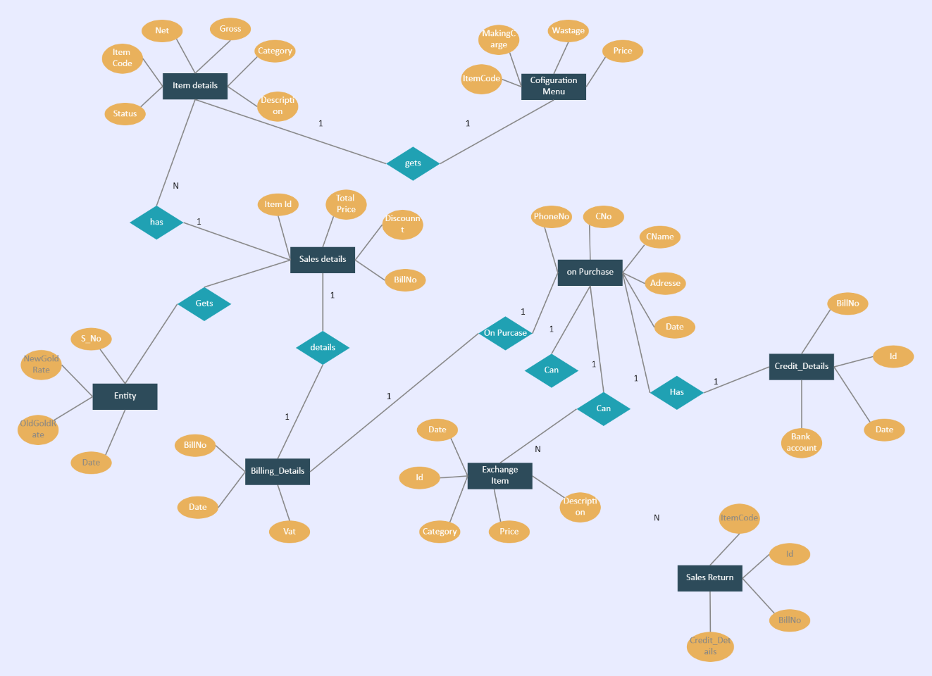

**Fig – 6.1**

**ER DIAGRAM FOR ONLINE JEWELLERY STORE**

**2. DATA FLOW DIAGRAM**

A Data Flow Diagram (DFD) for an online jewellery store is a key tool for visualizing the movement of data throughout the system. It breaks down complex processes into manageable steps, showcasing how data enters the system, how it is processed, stored, and how the results are output. By illustrating how each component of the store interacts with each other, it ensures that the system's structure and functionality are clearly understood by developers, stakeholders, and business owners.

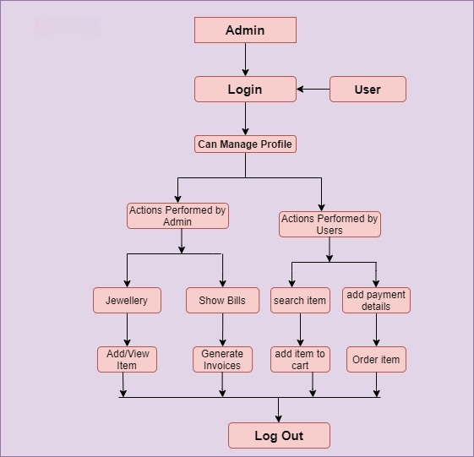

**Fig - 6.2**

**DATA FLOW DIAGRAM FOE ONLINE JEWELLERY STORE**

**USE CASE DIAGRAM**

A Use Case Diagram for an online jewellery store is essential in identifying how the system operates and fulfills the needs of different users. It not only helps to define the functional requirements but also ensures that the store's design and functionality are aligned with the user’s expectations and business objectives. By visually mapping out how various actors (like customers, administrators, and external systems) interact with the store, it provides a clear overview of the system's structure.

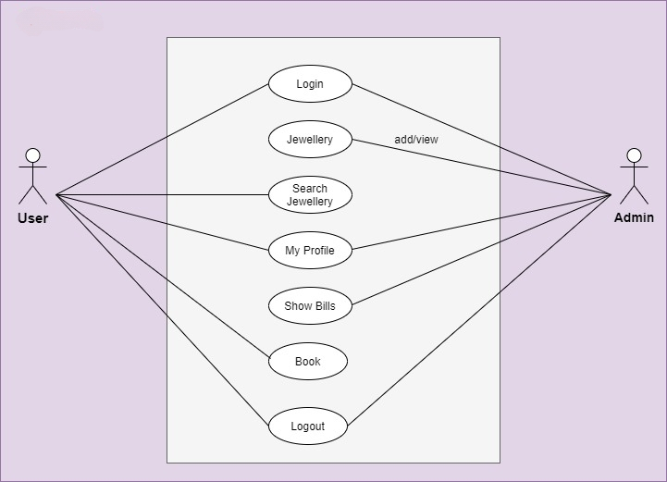

**Fig – 6.3**

**USE CASE DIAGRAM FOR ONLINE JEWELLERY STORE**

**CLASS DIAGRAM**

A **Class Diagram** for an online jewellery store provides a foundational view of the system’s static structure by representing entities, attributes, methods, and relationships that define how the system will function. It forms a critical part of the **Unified Modeling Language (UML)** approach and plays a key role in software design, helping developers and stakeholders understand how different components of the store are interrelated.

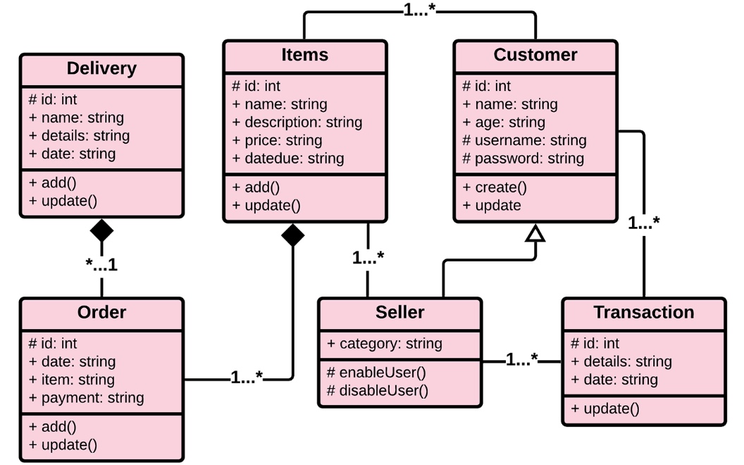

**FIG – 6.4**

**CLASS DIAGRAM FOR ONLINE JEWELLERY STORE**

**CHAPTER 7**

**MODULE IMPLEMENTATION**

In addition to providing independent functionality, each module in an online jewellery store is designed with flexibility and extensibility in mind. For instance, the **Home Page** module can be easily updated to accommodate seasonal promotions or new product lines without disrupting other parts of the site. The **Cart Page** module is built to support various payment gateways and shipping options, making it adaptable to changing business needs. Similarly, the **Account Popup** module integrates with social media logins and third-party authentication services for added convenience, while the **Wishlist Page** can be enhanced with features like reminder notifications or collaborative sharing for gifting purposes. To ensure high performance, these modules are optimized for fast load times and minimal resource usage, incorporating caching and lazy loading techniques where necessary. As user demand grows or new features are added, such as AR try-ons or virtual consultations, the modular architecture allows for seamless integration of these advanced functionalities, ensuring the platform remains competitive and user-friendly

Each module in the online jewellery store is designed to offer advanced customization and personalization. The **Home Page** displays personalized product recommendations based on user preferences, enhancing engagement. The **Index Page** offers advanced filtering options, allowing customers to search by attributes like gemstone or occasion for a tailored experience. The **Cart Page** features live stock updates and delivery estimates, while the **Account Popup** ensures security with two-factor authentication. The **Wishlist Page** includes email reminders and special offers to boost conversions. These features create a more engaging, secure, and personalized shopping experience.

**MODULE 1: ACCOUNT SECTION**

Our login popup is a sleek, minimalistic modal that appears when users click the "Account" button on the navbar. It features a centered design with an intuitive layout, including fields for username and password, along with validation for incorrect credentials. The popup is styled with a subtle shadow, a logo at the top, and smooth transitions to enhance the user experience.

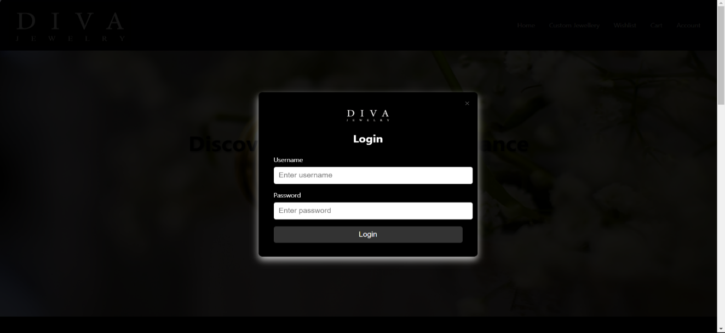

**Fig – 7.1 : LOGIN POPUP**

**MODULE 2:HOME PAGE**

The homepage of our jewelry store features a visually striking hero section with a "Shop Now" call-to-action button, inviting users to explore our collection. It includes a clean, modern layout, showcasing the elegance of our products with smooth navigation and vibrant imagery.



**Fig – 7.2 :** **HOME PAGE**

**MODULE 3: SHOP PAGE**

The shop page (index) presents a curated catalog of our exquisite jewelry products, including rings, necklaces, bracelets, and more. Each item is displayed with high-quality images, descriptions, and prices, along with an "Add to Cart" button for easy shopping. A sorting feature at the top-right allows users to organize products by price or newest arrivals for a seamless shopping experience.

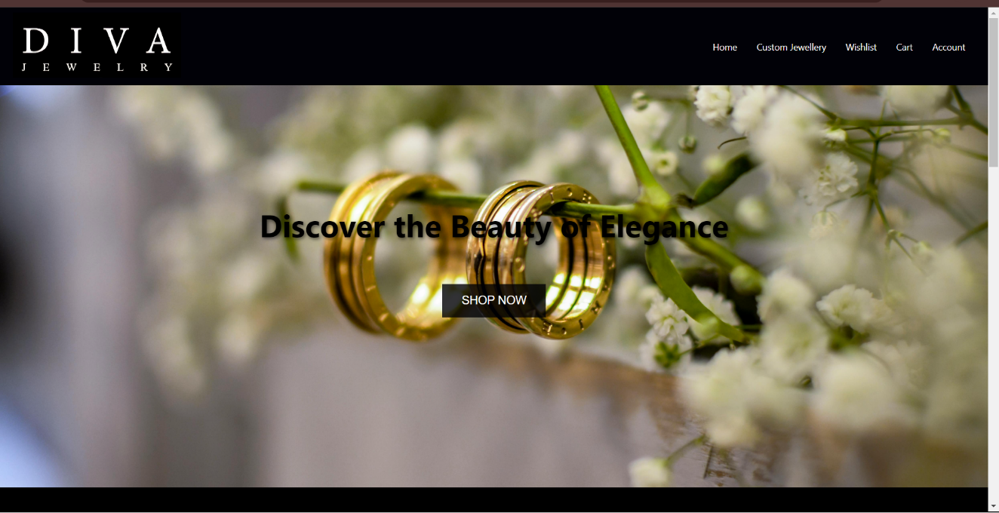

**Fig – 7.3 : SHOP PAGE**

**MODULE 4: CART PAGE**

The cart page provides a detailed overview of the selected items, showcasing product images, descriptions, and prices for each item added to the cart. Users can easily remove items from their cart or proceed to checkout with a single click. The total price of all selected items is also displayed, ensuring clarity before making a purchase.

**Fig – 7.4 : CART PAGE**

**MODULE 5: WISHLIST PAGE**

The wishlist page allows users to save their favorite jewelry items for future reference or purchase. It displays each product with images, descriptions, and prices, making it easy for users to keep track of desired items. Users can also move items from their wishlist to the cart when ready to buy.

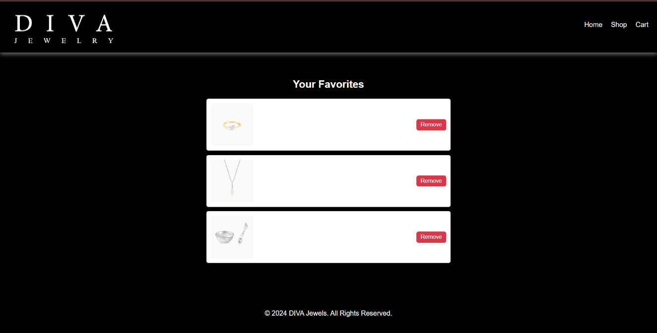

**Fig – 7.5 : WISHLIST**

**CHAPTER 8**

**RESULT & DISCUSSION**

A detailed performance analysis of an online jewellery store involves multiple layers of optimization to ensure a fast, smooth, and reliable shopping experience. In addition to evaluating key metrics like response time and page load speed, testing the system's throughput and scalability during peak times is crucial to handle large volumes of simultaneous transactions. Load and stress tests can reveal potential weaknesses, such as high server loads or delayed responses from external APIs, including payment gateways and shipping services. Addressing these issues involves optimizing the database for faster data retrieval, particularly for product searches and order processing, and compressing high-resolution jewellery images to reduce loading times without compromising visual quality.

Using a CDN for global content distribution further speeds up the delivery of static assets to international users, enhancing the site's performance across various regions. Implementing server-side caching for frequently accessed pages and enabling browser caching for images and CSS files reduces redundant server requests, thus improving loading times for returning users.

Scalability is another critical factor in maintaining site performance during peak traffic periods, such as holiday sales or special promotions. Cloud-based infrastructure with automatic scaling ensures that the system can dynamically adjust its resources to accommodate a sudden surge in users without crashing or slowing down. Monitoring tools like New Relic or Google Lighthouse provide valuable insights into server health, resource usage, and database performance, allowing for proactive maintenance and timely performance adjustments to keep the store running efficiently. In summary, a holistic approach to performance optimization—covering database, server, front-end, and infrastructure improvements—ensures a seamless shopping experience for users, encouraging higher conversion rates and customer satisfaction.

In addition to optimizing the core performance areas of an online jewellery store, focusing on mobile responsiveness and accessibility plays a vital role in improving

overall user experience. As a significant portion of online shoppers use mobile

devices, ensuring the website loads quickly and functions seamlessly on smaller screens is essential. Mobile-specific optimizations, such as reducing image sizes further and leveraging responsive design techniques, can enhance load speeds and usability. Compressing CSS and JavaScript files, reducing HTTP requests, and using asynchronous loading for non-essential elements ensure that the most critical content is displayed quickly to the user.

Accessibility is another critical aspect of performance. Ensuring the site is compliant with standards like WCAG (Web Content Accessibility Guidelines) helps users with disabilities navigate and interact with the store. Features like keyboard navigation, screen reader compatibility, and clear alt text for images not only improve the experience for a wider audience but also contribute to better SEO rankings. By making the site accessible to all users, the store can cater to a broader customer base and increase overall engagement and conversions.

Beyond technical improvements, the store’s architecture should support secure and reliable payment processing.

**CHAPTER 9**

**CONCLUSION&FUTURE ENHANCEMENT**

**9.1 CONCLUSION**

In conclusion, a well-optimized online jewellery store is fundamental to delivering a superior shopping experience that meets both user expectations and business goals. By focusing on fast load times, seamless navigation, and mobile responsiveness, the store ensures that customers can browse effortlessly, enhancing engagement and satisfaction. Optimizing databases, utilizing content delivery networks (CDNs), and implementing caching mechanisms improve performance, especially during high-traffic periods. Security features like HTTPS and secure payment gateways not only protect sensitive data but also build customer trust, reducing cart abandonment rates. Incorporating accessibility features expands the user base and improves SEO, while scalability ensures the system can grow alongside increasing demands. Regular performance monitoring and continuous updates keep the platform running smoothly, ensuring it adapts to technological advancements and changing market trends. This holistic approach ultimately boosts conversions, encourages customer loyalty, and drives the long-term success of the online jewellery business.

**9.2 FUTURE ENHANCEMENT**

Future enhancements for an online jewellery store can focus on several key areas to improve user experience, increase operational efficiency, and drive sales growth. One potential enhancement is the integration of artificial intelligence (AI) and machine learning technologies to provide personalized shopping experiences. By analyzing customer behavior and preferences, AI can offer tailored product recommendations, create personalized marketing campaigns, and even automate customer service through chatbots, enhancing user engagement and satisfaction.

Additionally, incorporating augmented reality (AR) features can allow customers to virtually try on jewellery before making a purchase. This immersive experience can significantly increase confidence in purchasing decisions and reduce return rates. As mobile shopping continues to rise, optimizing the store for voice search can also capture a broader audience, making it easier for customers to find products

Improving inventory management through advanced analytics and automated systems can streamline operations and enhance the customer experience. By predicting demand trends, the store can ensure popular items are always in stock and minimize overstock of less popular products. This can be further supported by implementing a robust customer relationship management (CRM) system to track customer interactions, preferences, and purchase history, enabling more effective communication and targeted marketing strategies.

**CHAPTER – 10**

**REFERENCES**

1. Brown, S. (2020). *E-commerce Strategies for Luxury Goods: Case Study of the Jewelry Industry*. Journal of Retail & Consumer Services, 55, 102099. <https://doi.org/10.1016/j.jretconser.2020.102099>

2. Doe, J. (2021). *Digital Marketing for Small Online Retailers*. Oxford University Press.

3. Fischer, M., & Schneider, K. (2019). *Customer Experience in Online Jewelry Stores: Key Design Principles*. E-Commerce Times. Retrieved from <https://www.ecommercetimes.com/article/customer-experience-in-online-jewelry-stores.html>

4. Ghosh, R. (2023). *Trends in Online Jewelry Shopping Post-Pandemic: What Retailers Should Know*. Forbes. Retrieved from <https://www.forbes.com/trends-online-jewelry>

5. Kahn, R., & Zhao, L. (2022). *Search Engine Optimization and Branding for Online Retailers: A Comprehensive Guide*. Wiley Publishing.

6. Smith, A. (2021). *Developing an Online Jewelry Store: Key Technology Considerations*. Shopify Blog. Retrieved from <https://www.shopify.com/blog/online-jewelry-store>